The BSG wishes to continue to support international projects led by its members leading to a sustainable partnership or defined improvement in the following areas:
- Leadership
- Service improvement
- Educational initiatives
These should enhance knowledge or organisational development, with the overall goal of providing the best care and outcomes for patients with gastrointestinal and liver diseases in settings across the world.
The main requirements of the project proposal are:
- The project aims should improve training or service delivery in aspects of gastrointestinal disease management for the benefit of patients.
- The project should promote high-quality, evidence-based practice.
- The project team should comprise sufficient experience to effectively deliver the main aims of the project.
- There should be evidence of local engagement with the service / hospital / academic institution / government where the visit is being conducted.
- The project should have clearly defined ‘SMART’ aims and objectives. These should be explained within the context of the BSG International ‘Levels of Development’.
- A detailed financial break-down of costs and expenses should be provided of how the Grant would be used.
In recent years, the emphasis of Grants Awards has been on support for specific projects in low resource settings. This year the International Committee is seeking to broaden the scope of the Grants Awards and types of projects supported. Examples of previous projects can be found in the BSG International Strategy.
Criteria
Applications are welcomed across all areas of gastroenterological practice, be it predominantly a medical, nursing or AHP focus, in adult or paediatric settings, but an emphasis on demonstrating how the project will lead to a sustainable partnership or defined improvement will be central to the renewed application process. The applicant/partnership must include a current member of the BSG, at least one of whom will usually be in current practice in the UK.
The maximum value of a single grant award is £10,000. Detailed evaluation of the submitted costings for the project will be performed by the Project Assessment Committee in deciding what level of grant may be awarded to individual projects.
The funding is NOT intended for equipment other than that which is required for training or is purely educational in its use and only reasonable ‘standard rate’ travel and accommodation costs will be supported. The applicant/partnership must be/include a current member of the BSG. At least one member of the applicant/partnership should usually be in current practice in the UK.
Successful projects must be undertaken within 12 months of the award of the BSG International Grant Award (subject to any travel restrictions) and a report submitted to the BSG International Committee including achievement of project goals. You may also be invited to give a presentation at the BSG Annual Conference International Section Symposium.
Categories
Applications for BSG International Grants Awards will be considered in the following categories:
- New project proposal for a clinical visit.
- Returning project proposal from a team that has received a previous BSG International Grant Award.
- Funding to support a specific research project based overseas.
- Funding to support the development of educational resources that will be a valuable tool for training related to GI diseases.
Assessment information
A flow chart of the application process can be found below:
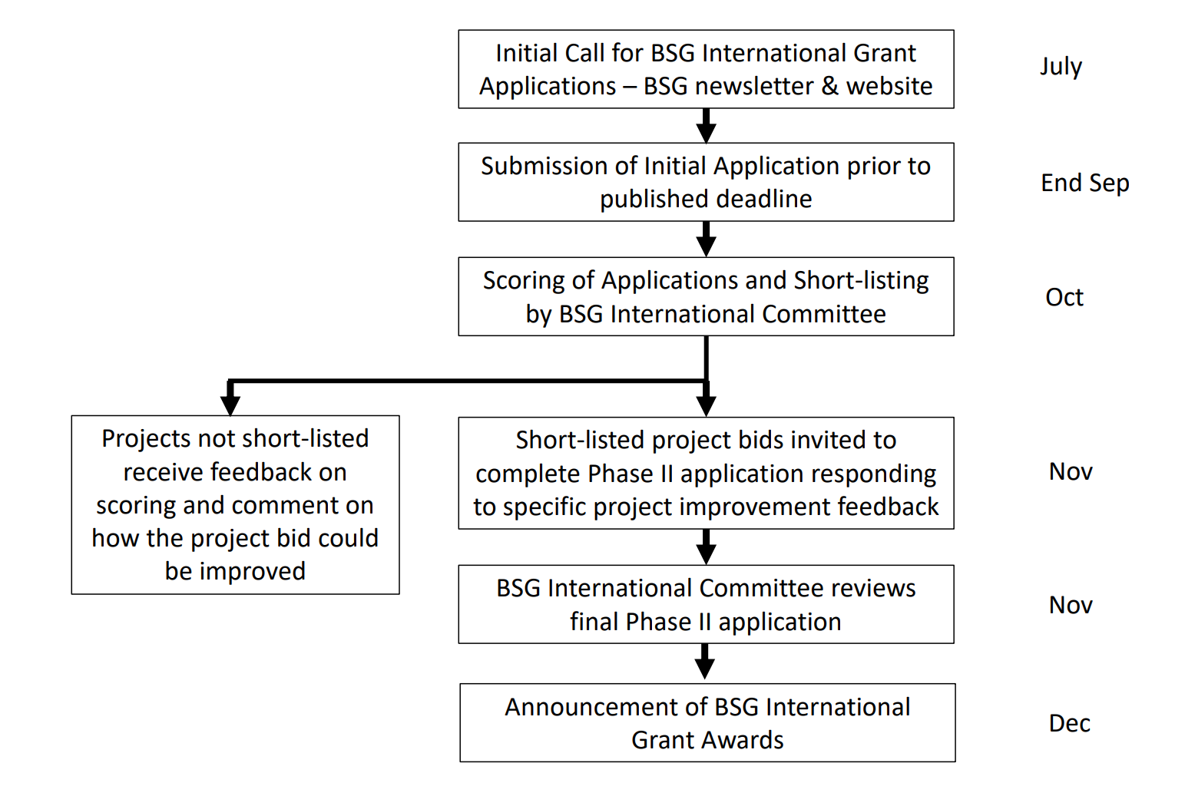
A detailed evaluation of the submitted costings for the project will be performed by the Project Assessment Committee in deciding what level of grant may be awarded to individual projects.
The Assessment Committee will be made up of members of the International Committee (including the individual Zonal Leads) and will also include at least one independent judge with a background or interest in International Development and/or Medicine to ensure fairness and transparency of the award process.
All submitted applications will be reviewed by an initial panel of three BSG International Committee members. Specific project rating criteria will be applied to each application, shown below.
All applications will be assessed independently by scoring each of the six domains using a scale of 0-3;
Domains | Score (0-3)
Project proposal has ‘SMART’* aims and objectives
Project team experience is sufficient to deliver project aims
Project has specific local / regional support to complete project effectively and safely
Project proposal will meet specific needs aligned with the strategic aims of the BSG International section
Project proposal will deliver extra-added value in the development of educational resources or conducting primary research
Project has a clear legacy value or potential for sustainable BSG partnership
TOTAL (max score = 18)
*SMART aims and objectives = Specific, measurable, achievable, resources, time (sufficient)
Key to scoring of criteria;
0= Domain criteria not met at all
1= Some areas of the domain will be met, lacking detail or some doubts about delivery
2= Most areas of the domain will be met, some details given but could be improved
3= Domain criteria will be met, clear outline of how this could be achieved
Projects achieving a threshold scoring level will be asked to submit a second more detailed application which will include responses to specific questions raised by the Assessment Panel and may require the incorporation of specific additional aims and objectives or aspects of project design and delivery that, in the opinion of the panel, will improve the quality of the project and its measurable outcomes.
The final approval of Phase II applications will be made by the BSG International Committee or Panel. The Committee (or Panel) must be satisfied that the following criteria have been met:
- The project team have responded appropriately to feedback in their Phase II application.
- Project aims and objectives are clear and realistic.
- Project team has the requisite experience to act as BSG Ambassadors.
- Costings are reliable and transparent.
- Appropriate measurable outcomes are set for project evaluation.
- Requirements for partnership development are clearly stated

